QO-100 WB Spectrum Ryde Tuner
User & Operator Manual
User & Operator Manual
Live QO-100 wideband spectrum viewing and receiver channel selection
Version 1.1 — September 2026
System Overview
The QO-100 wideband transponder is an approximately 8–9 MHz linear amateur-radio repeater payload aboard
Es'hail-2 (Qatar-OSCAR 100), used primarily for digital amateur television (DATV) and other wideband
transmissions.

Parameter | Value
Orbit | Geostationary at 25.9° East
Uplink | 2401.5–2409.5 MHz
Downlink | 10491.0–10499.0 MHz
Bandwidth | Approximately 8–9 MHz
Polarisation | Horizontally polarised

Foot print of the QO-100 Satellite show the surface area of the world covered by the satellite
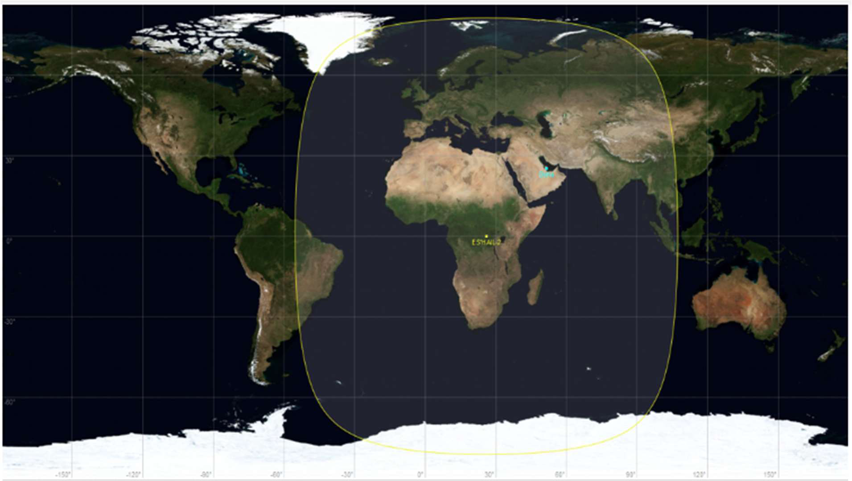

Live Viewing
SRT Stream | srt://g8koe.ddns.net:8890?streamid=read:qo100
Web Chrome Browser | http://g8koe.ddns.net:8888/qo100/
Web Browser Tune Control | http://webtune.lebs.org.uk:5000

Receiver Control Web Interface
To be able to control the tuning of the satellite receiver open a web page and navigate to http://webtune.lebs.org.uk:5000/
Receiver-control page showing the live spectrum, frequency field, symbol-rate selector and Tune Ryde control.
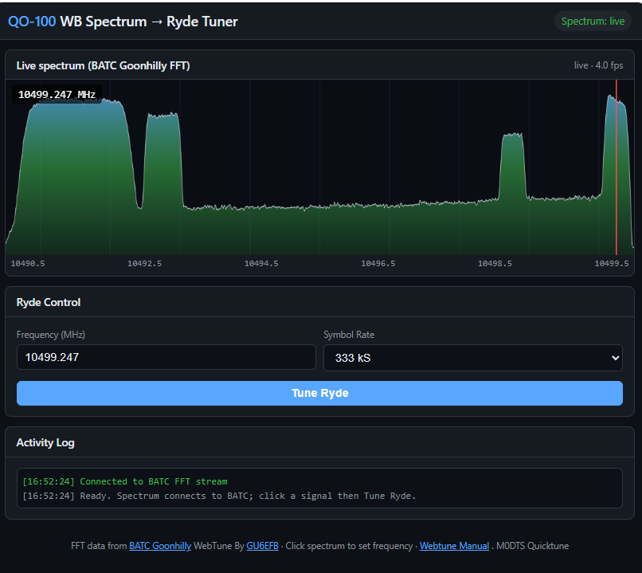

Connecting to the QO-100 SRT Channel
Use the following sequence:
- Open your chosen SRT-capable viewing software.
Recommended software is the Haivison Play ISR Video Player software, Link to software below.
https://www.haivision.com/products/download-play-isr

- Open web control page.
http://webtune.lebs.org.uk:5000/
3. Confirm that DATV video is being received.

Example DATV video received from the QO-100 SRT stream.
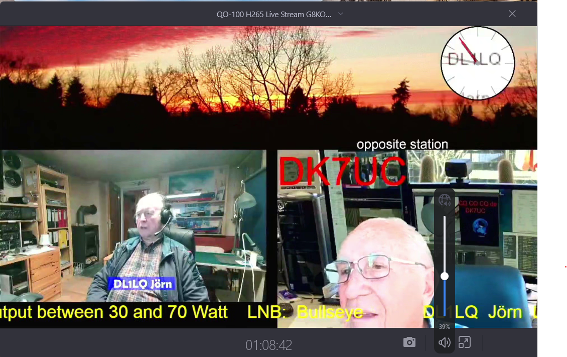
If no transmission is visible, open the receiver-control web interface and check the spectrum and available
channels.

Selecting and Tuning a DATV Channel
The spectrum display represents the wideband transponder and allows a transmission to be selected directly.
The normal operating sequence is:
1. Locate the required DATV signal on the spectrum.
2. Move the mouse pointer to the centre of the signal.
3. Click the centre of the transmission.
4. Symbol rate selection should be automatic when the required signal to view has been selected by clicking on the spectrum display, but you have the option from the drop down menu to choose a symbol rate.
5. Click the blue Tune Ryde button.
The receiver should tune to the selected channel and the transmission should appear in the SRT player or
browser window.

Symbol Rate Selection
The selected symbol rate must match the transmission being tuned. The supplied operating example specifically
uses 500 KS. If the symbol rate does not match the transmission, the Ryde receiver will not correctly decode or
display the DATV service.

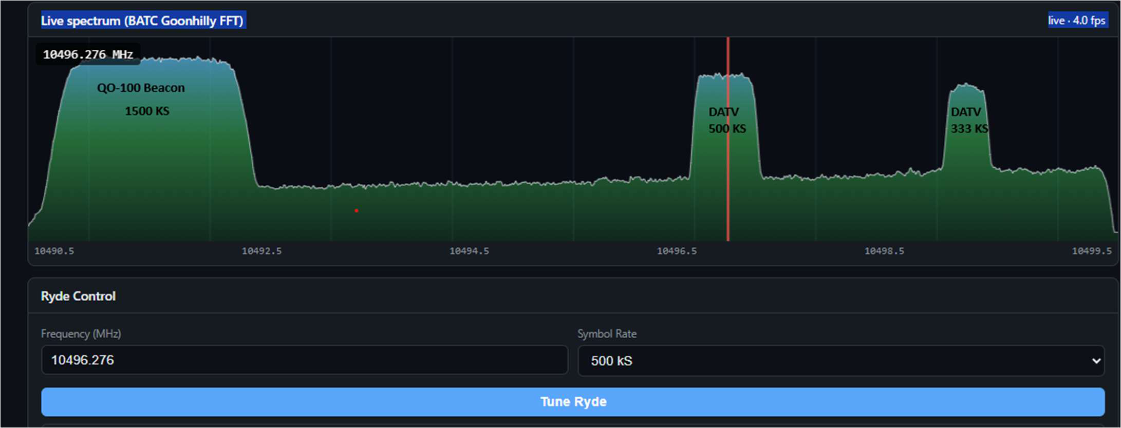

Beacon Failure Condition
Note that the QO-100 beacon can occasionally fail. When this occurs, receive picture
may no longer look normal, we just have to wait until the beacon resets its self-back to normal.

Example of the abnormal DATV display

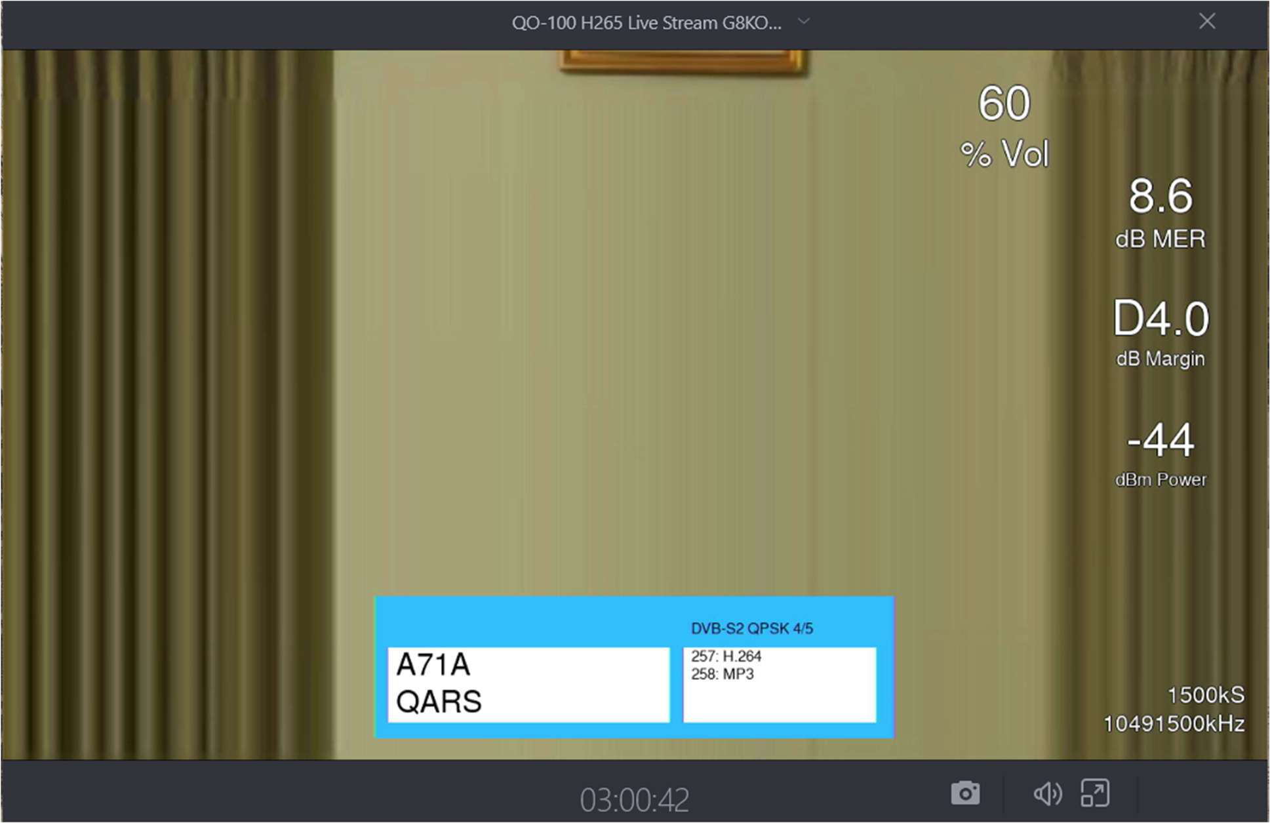

Troubleshooting Qatar-OSCAR 100
Receiver does not tune
Confirm a signal is selected, the correct symbol rate is chosen and Tune Ryde is pressed.
Picture is not decoded
Verify that the selected symbol rate matches the transmission.
Control page will not open
Confirm the actual receiver http://webtune.lebs.org and port 5000.are selected
Please note that depending on the format of the transmission from the originating station not all transmissions are receivable.
Only one QO-100 SRT channel available, if more than one operator selects a channel using the WebTune application we will end up with the channel constantly changing. I will at how best to resolve this issue when time allows so please play fair when using this system.

Support and Feedback
For general comments, suggestions or offers of help email gu6efb@lebs.org.uk
Most importantly have fun and enjoy the hobby.
Thanks to the Qatar-OSCAR 100, BATC, Amsat DL, G8KOE for use of the SRT Repeater and Rob M0DTS for the inspiration from his Quicktune software
 https://batc.org.uk/

